**MY SQL QUERIES**

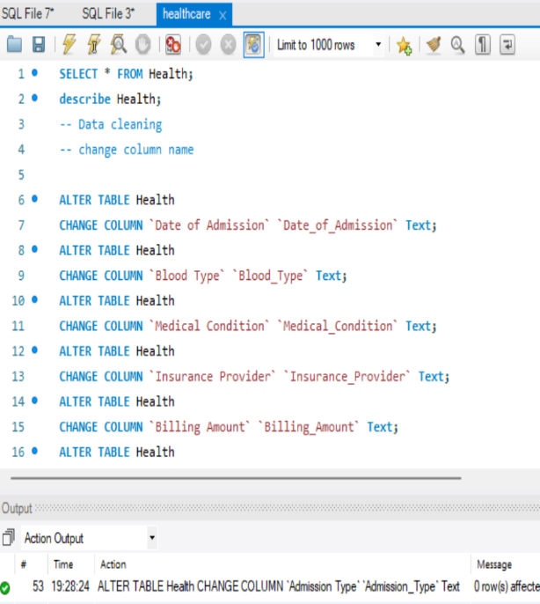**Data cleaning**

**Change Column Name:**

* ALTER TABLE Health

CHANGE COLUMN `Date of Admission` `Date_of_Admission` Text;

* ALTER TABLE Health

CHANGE COLUMN `Blood Type` `Blood_Type` Text;

* ALTER TABLE Health

CHANGE COLUMN `Medical Condition` `Medical_Condition` Text;

* ALTER TABLE Health

CHANGE COLUMN `Insurance Provider` `Insurance_Provider` Text;

* ALTER TABLE Health

CHANGE COLUMN `Billing Amount` `Billing_Amount` Text;

* ALTER TABLE Health

CHANGE COLUMN `Room Number` `Room_Number` Text;

* ALTER TABLE Health

CHANGE COLUMN `Admission Type` `Admission_Type` Text;

* ALTER TABLE Health

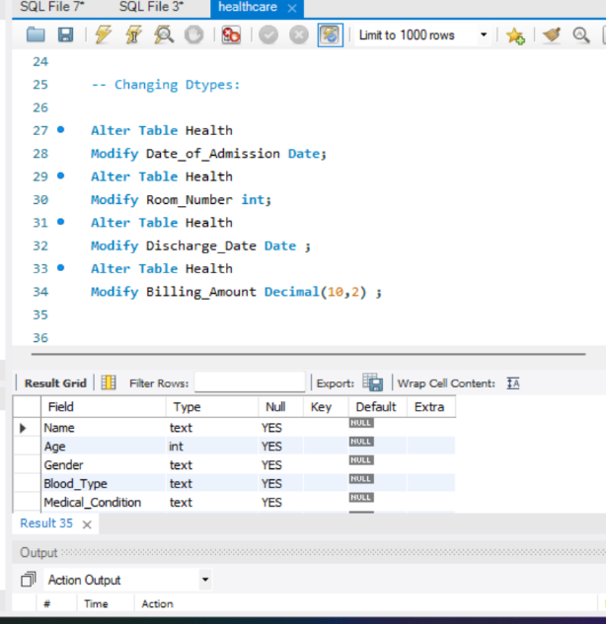CHNGE COLUMN `Discharge Date` `Discharge_Date` Text;

* ALTER TABLE Health

CHANGE COLUMN `Test Results` `Test_Results` Text;

**Changing Data Types:**

* Alter Table Health

Modify Date_of_Admission Date;

* Alter Table Health

Modify Room_Number int;

* Alter Table Health

Modify Discharge_Date Date;

* Alter Table Health

Modify Billing_Amount Decimal(10,2);

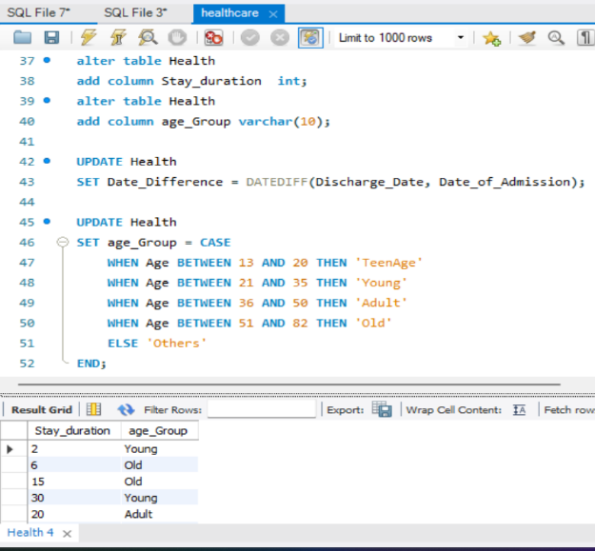

**Add Extra Columns (Feature Engineering)**

* alter table Health

add column Stay_duration int;

* alter table Health

add column age_Group varchar (10);

* UPDATE Health

SET Date_Difference = DATEDIFF (Discharge_Date, Date_of_Admission);

UPDATE Health

SET age_Group = CASE

WHEN Age BETWEEN 13 AND 20 THEN 'TeenAge'

WHEN Age BETWEEN 21 AND 35 THEN 'Young'

WHEN Age BETWEEN 36 AND 50 THEN 'Adult'

WHEN Age BETWEEN 51 AND 82 THEN 'Old'

ELSE 'Others'

END;

**Data Analysis:**

* **What are the total number of patients admitted to the hospital?**

SELECT count (Name) as Total_No_of_Patient

FROM Health;

* **Find the most common medical condition in?**

SELECT Medical_Condition, COUNT (*) AS Most_common

FROM Health

GROUP BY Medical_Condition

ORDER BY Most_common DESC

LIMIT 1;

* **List all hospitals and the number of patients admitted to each?**

SELECT Hospital, count(Name) as total_Patient

From Health

Group by Hospital

ORDER by total_patient Desc;

* **What is the total Billing Amount?**

SELECT

CASE

WHEN SUM(Billing_Amount) >= 1000000000 THEN

CONCAT(ROUND(SUM(Billing_Amount) / 1000000000, 2), " B")

WHEN SUM(Billing_Amount) >= 1000000 THEN

CONCAT(ROUND(SUM(Billing_Amount) / 1000000, 2), " M")

ELSE

CONCAT(ROUND(SUM(Billing_Amount), 2), " ")

END AS Total_Billing_Amount

FROM Health;

* **List of doctors and the total number of patients they have treated?**

SELECT Doctor, count(Name) as total_Patient

From Health

Group by Doctor

ORDER by total_patient Desc;

* **Calculate the average Patient Admitted per day?**

SELECT ROUND(COUNT(Name) * 1.0 / COUNT(DISTINCT Date_of_Admission), 2) AS Avg_Patients_Addmited_Per_Day

FROM Health;

* **Find the total number of patients admitted by gender and medical condition?**

SELECT Gender,Medical_Condition,Count(Name) As Count_Of_Patient

FROM Health

Group By Gender,Medical_Condition;

* **Find the average recovery Day for each Medical Condition?**

SELECT Medical_Condition,

ROUND(AVG(Stay_Duration), 2) AS Avg_Recovery_Days

FROM Health

WHERE Stay_Duration IS NOT NULL

GROUP BY Medical_Condition

ORDER BY Avg_Recovery_Days DESC;

* **Calculate the total billing amount for each insurance provider and the number of patients covered?**

SELECT Insurance_Provider,

SUM(Billing_Amount) AS Total_Billing_Amount,

COUNT(DISTINCT Name) AS Number_of_Patients_Covered

FROM Health

WHERE Insurance_Provider IS NOT NULL

GROUP BY Insurance_Provider

ORDER BY Total_Billing_Amount DESC;

* **Find the doctors with the highest and lowest average patient loads per month?**

SELECT Doctor,

ROUND(AVG(Monthly_Patient_Load), 2) AS Avg_Patient_Load_Per_Month

FROM (

SELECT Doctor,

YEAR(Date_of_Admission) AS Admission_Year,

MONTH(Date_of_Admission) AS Admission_Month,

COUNT(Name) AS Monthly_Patient_Load

FROM Health

WHERE Date_of_Admission IS NOT NULL

GROUP BY Doctor, YEAR(Date_of_Admission), MONTH(Date_of_Admission)

) AS Monthly_Patient_Data

GROUP BY Doctor

ORDER BY Avg_Patient_Load_Per_Month DESC;

* **What are the trends in admissions over time?**

SELECT DATE_FORMAT(Date_of_Admission, '%Y-%m') AS Month, COUNT(*) AS Admission_Count

FROM Health

GROUP BY DATE_FORMAT(Date_of_Admission, '%Y-%m')

ORDER BY Month;

* **calculate the 3-month moving average of the billing amount for each doctor?**

SELECT

Doctor,

YEAR(Date_of_Admission) AS Year,

MONTH(Date_of_Admission) AS Month,

SUM(Billing_Amount) AS Total_Billing,

AVG(SUM(Billing_Amount)) OVER (PARTITION BY Doctor ORDER BY YEAR(Date_of_Admission), MONTH(Date_of_Admission) ROWS BETWEEN 2 PRECEDING AND CURRENT ROW) AS Moving_Avg_Billing

FROM Health

GROUP BY Doctor, YEAR(Date_of_Admission), MONTH(Date_of_Admission)

ORDER BY Doctor, Year, Month;

